Development Platform Introduction

**Jiashu Wu**

2018.06

© Jiashu Wu 2018

Development Platform Introduction for Neurograph Version 1.0 and Version 1.1

2018.06

Table of Contents

1. Introduction and Notes 4

2. IDE 5

3. Gradle Build Version 6

4. SDK Information 6

5. Version Control Platform 6

6. Testing Device and Android Version 7

7. Testing Virtual Device and Android Version 7

8. Virtual Device Configuration 8

9. External Jar Files 9

9.1 Java Mail for Android 9

# 1. Introduction and Notes

This document explains the detail of the development platform, testing platform and some of the resources used during the development process.

**Please note** that the development platform used when developing Neurograph Version 1.0 and Version 1.1 were the same.

# 2. IDE

Android Studio 3.0.1

Build #AI-171.4443003, built on November 10, 2017

JRE: 1.8.0_152-release-915-b01 amd64

JVM: OpenJDK 64-Bit Server VM by JetBrains s.r.o

Windows 10 10.0

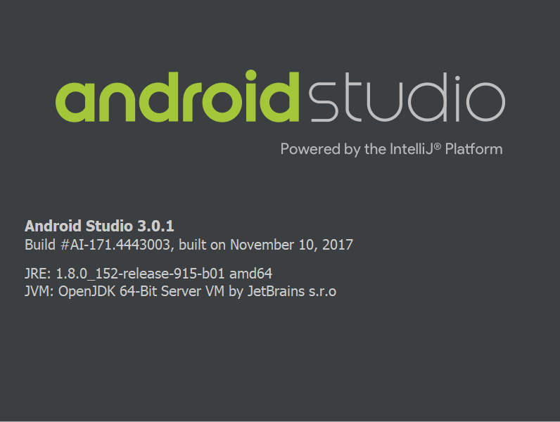

Download Link: <https://developer.android.com/studio/archive?authuser=1>

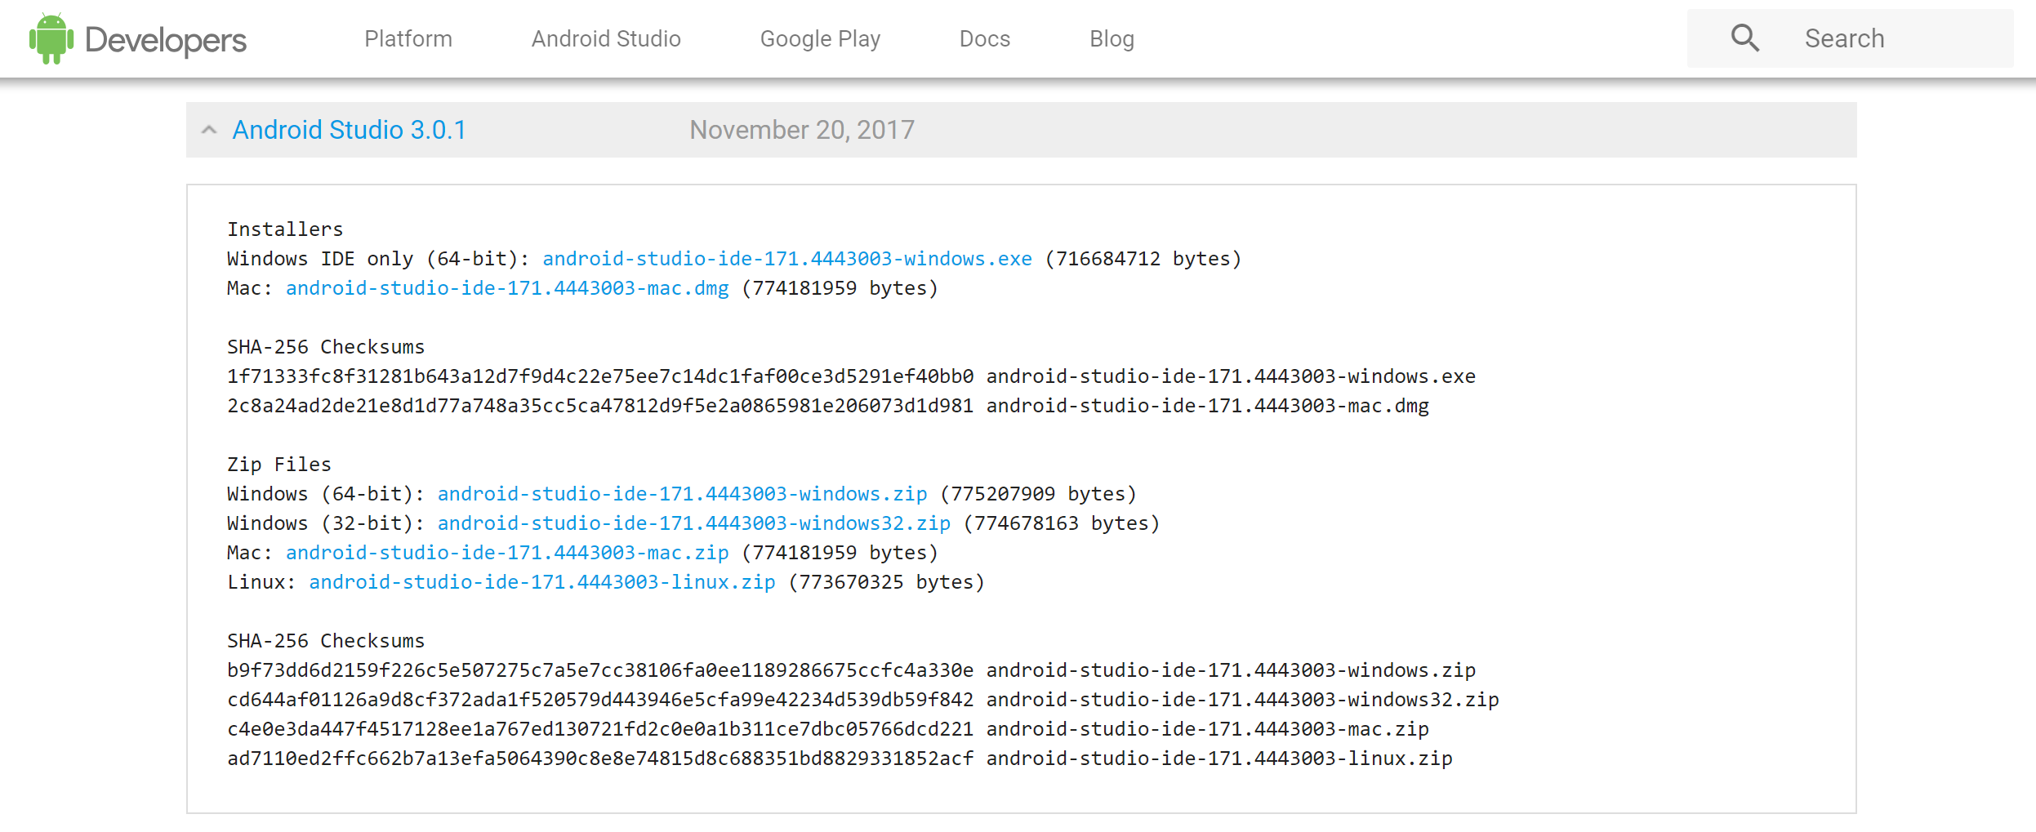

# 3. Gradle Build Version

Gradle Build Version: 3.0.1

# 4. SDK Information

Application Targeted SDK: 26

Application Minimum SDK: 15

# 5. Version Control Platform

Version Control Platform: Github

Repository name: NeuroGraph

Repository link:

<https://github.com/JiashuWu/NeuroGraph>

# 6. Testing Device and Android Version

Samsung Tab A with S Pen, with Android 7.1.1

Huawei FIG-AL10, with Android 8.0.0

# 7. Testing Virtual Device and Android Version

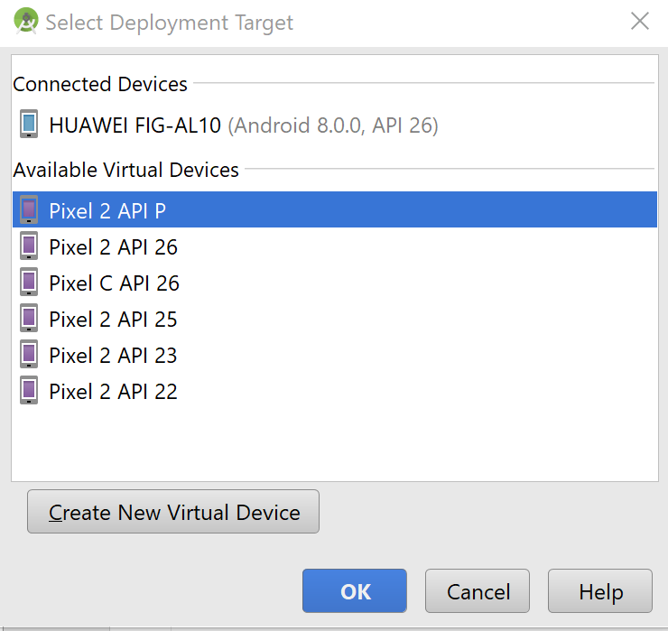Google Pixel 2 with Android P

Google Pixel 2 with Android 8.0.0

Google Pixel C with Android 8.0.0

Google Pixel 2 with Android 7.1.1

Google Pixel 2 with Android 6.0

Google Pixel 2 with Android 5.0

# 8. Virtual Device Configuration

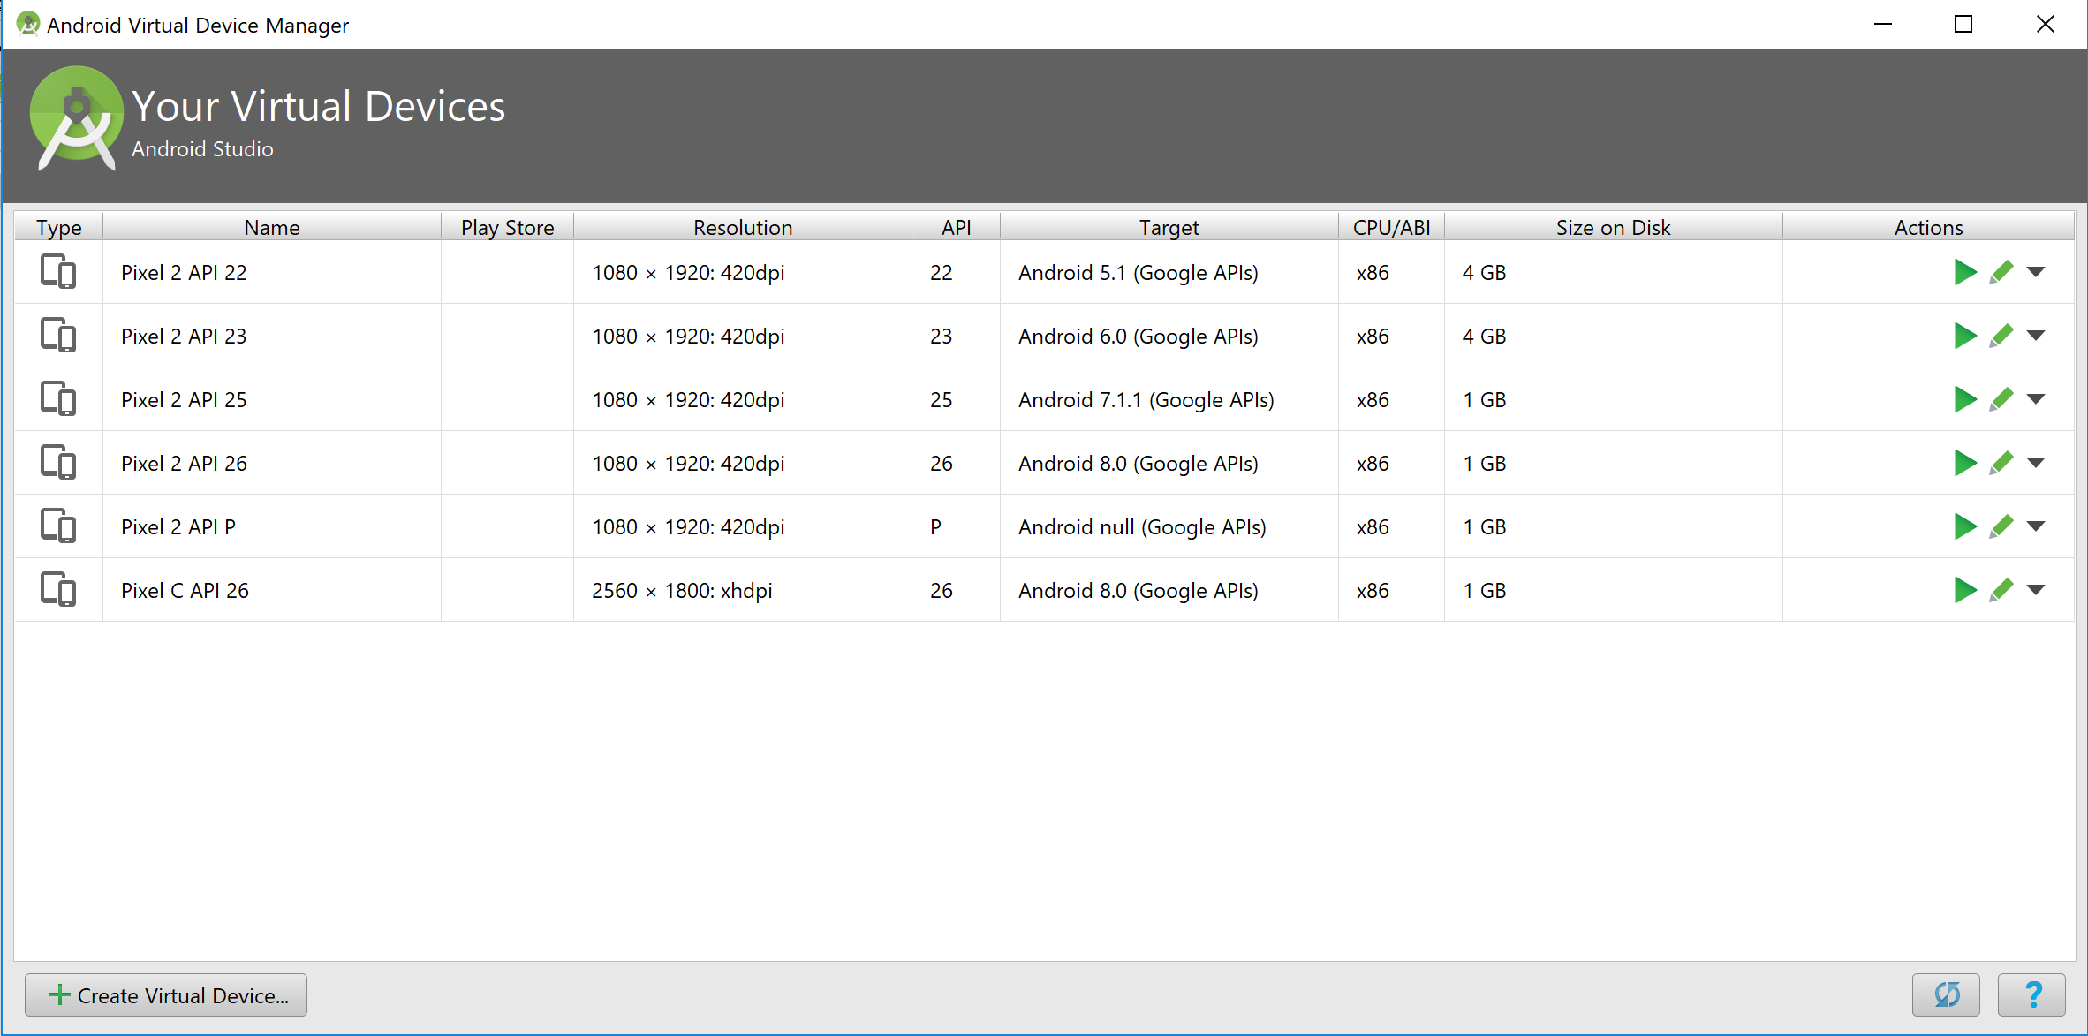

# 9. External Jar Files

## 9.1 Java Mail for Android

Download Links:

<https://code.google.com/archive/p/javamail-android/downloads>

